GUÍA DE AUTOEVALUACIÓN DE UNIDAD 1 “FEELINGS AND OPINIONS”
Guía n° 5 English Language

Nombre: |  | Curso: | 7th | Fecha

INSTRUCCIONES:
- Cuenta con 5 días para responder la guía.
- No se podrá entregar la guía sin estar resuelta completamente.
- La guía puede ser resuelta con apoyo de un diccionario y sus cuadernos de ser necesario. No está permitido copiar trabajos de otros compañeros/as.
- Utilizar lápiz pasta azul o negro.
- LA GUÍA DEBE SER ENTREGADA EL DÍA VIERNES 05 DE JUNIO HASTA LAS 16 HRS. al correo:
- pamela.roky@elar.cl
- LA GUÍA NO LLEVA NOTA

Objetivos: Demostrar conocimiento sobre expresar y dar opiniones y vocabulario temático.
Contenidos: Presente simple para expresar y dar opiniones con “like / likes or dislike /dislikes” y vocabulario sobre actividades de tiempo libre y de emociones y sentimientos.

ITEM I.- Choose the correct alternative for each sentence below. Please! Read carefully before choosing your alternative. Remember! This content is about Present Simple by expressing opinions.

- She _____ __ _____ apples.  - Dislikes to eat  - Hates to eat  - Loves to eat  - Can’t stand to eat | 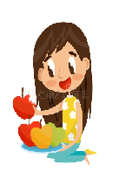 | - He ______ ____ __ ______ to music!  - Likes to listen  - Loves to listen  - Don’t like to listen  - Doesn’t like to listen | 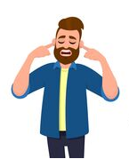
- He ______ __ ____ his bike.  - Hates to ride  - Adores to ride  - Dislikes to ride  - Can’t stand to ride | 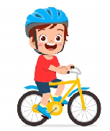 | - She ______ __ _____.  - Enjoys to dance  - Hates to dance  - Doesn’t like to dance  - Don’t like to dance | 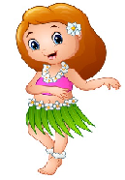
- He _____ _____ __ _____ dinner.  - Dislikes cook  - Can’t stand to cook  - Loves to cook  - Enjoys to cook | 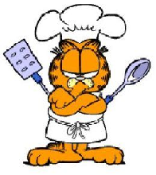 | - They ____ __ ____ cards together!  - Doesn’t like to play  - Can’t stand to play  - Don’t like play  - Like to play | 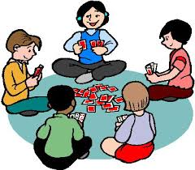

- They ____ __ ____ in the pool.  - Enjoy to swim  - Hate to swim  - Don’t like to swim  - Doesn’t like to swim | 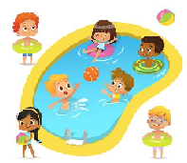 | - She ____ __ _____ sodas!  - Loves to drink  - Hates to drink  - Likes to drink  - Don’t like to drink | 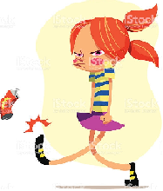

ITEM II.- Look carefully to the next emojis below, and then, choose the correct alternative for each one. Remember! This vocabulary is related to feelings and emotions.

- Embarrassed  - Sad  - Hungry  - Happy | 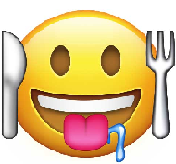 | 10)  a) Angry  b) In love  c) Sad  d) Scared | 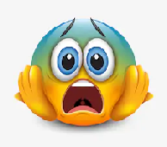
11)  a) In love  b) Scared  c) Angry  d) Embarrassed |  | 12)  a) Happy  b) Scared  c) Embarrassed  d) Hungry | 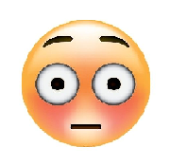

ITEM III.- Look at the pictures below and then, choose the correct alternative. Remember! This vocabulary is related to free time activities.

13)  a) taking photos  b) go for a walk  c) riding a bike  d) Reading a book | 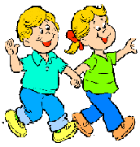 | 14)  - Skipping the rope  - Go for a walk  - Singing  - Doing a puzzle | 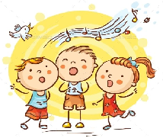

15)  - Doing origami  - Taking potos  - Reading  - Go for a walk |  | 16)  - Ride a bike  - Taking potos  - Singing  - Skipping the rope | 